There are big subgroups in our data men shoes and women's shoes. they are completely different and bundling them together when making predictions is going to yield deceiving results.

Not only feet differ by gender but also there are different shoe types are models.

Our problem is related to inventory management.

Therefore, we should divide our inventory in some way and then count the frequencies. that frequencies will give us a better idea of the data.

A good way to do that is to divide the data by shoe size

we have three Dimensions shoe size, country and gender.

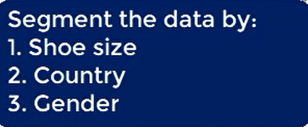

A possible solution is to create two table one for men's shoes and one for women's shoes and then proceed normally

We want to estimate the number of shoes that are likely to be and 95% confidence interval will give us such information.

We will take the last 12 months of sales and make a prediction. let's do this only for men shoes as the problem is identical for both genders.

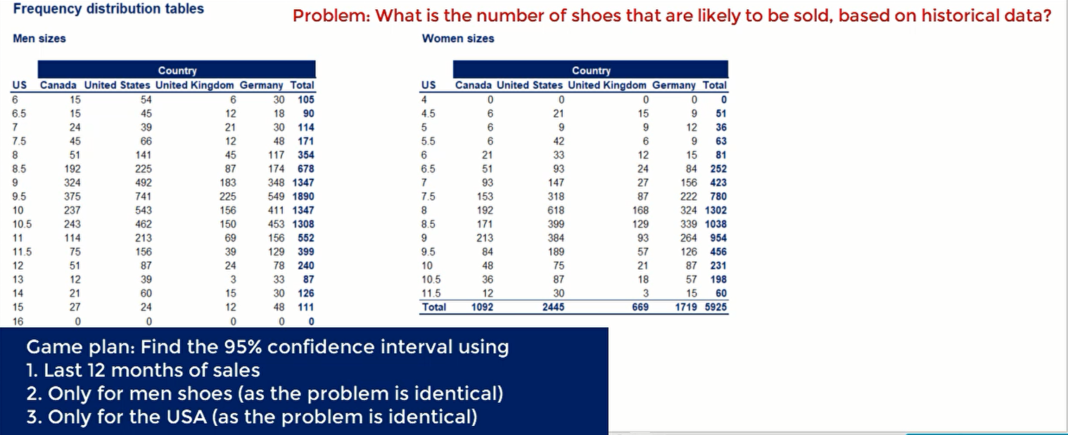

actually, we have to calculate 17 confidence intervals for each size. let's get on to it, first we need to calculate the mains.

  

We have a sample of 12 observations. therefore, we are looking for the t statistics for a 95% confidence interval with 11 degrees of freedom, it is 2.20





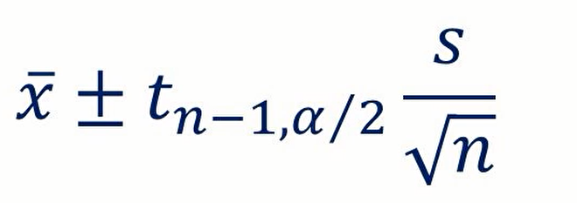 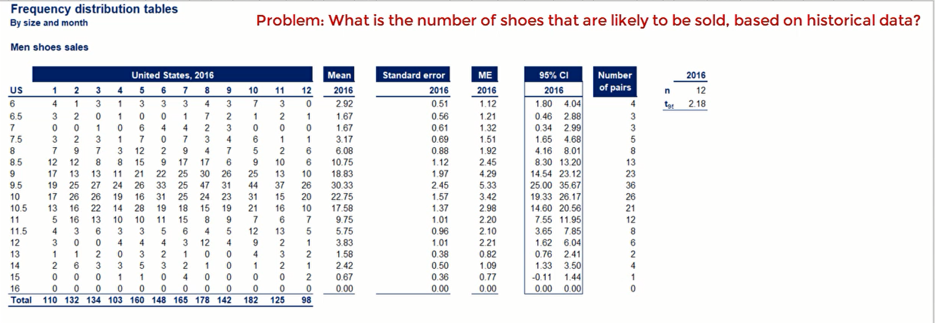

**The result of obtained can be interpreted as follows.**





mostly we should prepare ourselves with size 9.5 and size 16 won't yield in any sales.

sorry for those of you who are size 16 feet. I know it is hard enough to find shoes already but while this company would not be selling any.

* **we can see two tables representing the sales of women shoes into German shops**

now an assumption that we have to make is that the same people don't buy pairs of shoes form different shops



logically it makes sense that in the same year the same people don't go around different shops of the same brand buy shoes. Even if this happens it is an exception and not the norm.

 

Therefore, we can say that the two samples are independent, once again we don't know the population variance but given that this is the same market in the same country, we can assume it has equal.

